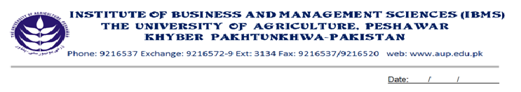
Program: BS (CS)-IV
Course Name: Introduction to Software Development
Course Code: CS-412
Credit Hours: 03
Course Week: 16
Total Hours: 48

Course Objectives
At the end of the course, student will be able to understand the basic concepts of S/W engineering, life cycle of system design, and the complexity involved in it. The students will also be able to optimize the system, making it error free, and concentrate on quality using traditional S/W Engineering approaches.

Week-1
-Introduction to System
-Introduction to S/W Engineering

Week-2
-S/W Process Models
-Linear Sequential
-Prototyping
Week-3
-S/W Prototyping
-Throw Away
-Evolutionary
Week-4
-Incremental Model
-Spiral Model

Week-5
-S/W Requirement
-Functional & Non Functional Requirements.
-User Requirements

Week-6
-System Requirements
-S/W Requirements

Week-7
-Elements of Analysis Modeling
The Data Dictionary.
-Data Modeling
-Data objects, Attributes, Relationships
-ERD with example

Week-8
-Functional Modeling

-DFD with example
-Behavioral Modeling
-STD with example

Week-9
S/W Design
-Data Design.

Week-10
-Architectural Styles
-Data centered architectures
-Data flow architectures
-Call and return architectures
-Object Oriented architectures
-Layered architectures
Week-11
-User Interface Rules
-Place the user in control
-Reduce the user’s memory load
-Make the interface consistent

Week-12
-Component/Level
-Graphical Design Notation.
-Tabular Design Notation.
-Program Design Lang.

Week 13
-Software Testing Strategies:
-Unit testing.
-Unit test considerations

Week-14
-Integration Testing.
-Top Down
-Depth first/Breath first approaches
-Bottom Up

Week-15
-Validation Testing.
- Alpha/beta Testing
-System Testing
-Recovery, Security, Stress, Performance
Week-16
-Revision

Total Marks: 100
Recommended Books
1. Software Engineering (Roger S. Pressman) 5 edition
2. Software Engineering (Ian Someruille) 6 edition

